Data: triDataLakePlacidFinal.json

Description: The motivation for this data analysis is to explore the relationships between bike times and run times (in minutes) in order to gain insights into the performance patterns of triathletes. By analyzing this relationship, we can understand the interplay between different segments of the race and potentially identify areas of improvement for athletes. For this activity, we will specifically focus on times from Canadian finishers in the 2018 Lake Placid Ironman.

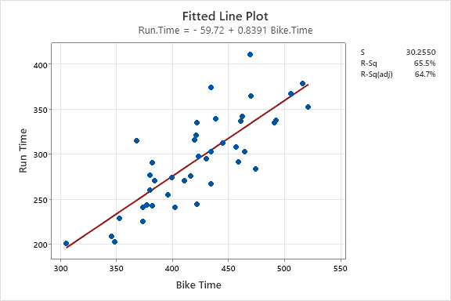

1. What is the explanatory variable in this situation? What is the response variable? What type are both variables?
2. What does each point in the scatterplot represent?
3. Report the least squares regression equation for predicting price from points.
4. April Clausen had a 470 minute bike time. What is her predicted run time?
5. April’s run time was 411 minutes. How far off was our prediction? Explain why we might see this observation.
6. Interpret the slope of the model in the context of the application. Be sure to be mindful of the units.
7. Interpret the intercept of the model in the context of the application.
8. Is the intercept interpretation meaningful? Explain.
9. What percent of variation in wine prices is explained by the model using Bike Time?
10. What is the sample correlation between run times and bike times?